Mallu Sravana Sandhya Python Assignment 20/12/23

1. Explain Python Module with examples

Module is a file containing python definations and file which can be used in another file simply by importing the module instead of redefining again and again  
a.Import module in Python

A module can be imported in any file using import keyword

Syntax:

import module_name

By using above syntax we can import all objects from the module

Inorder to import only particular objects we can use from keyword

Syntax

From module_name import object1,object2,..

We can use * to import all objects using from and import keywords

It can be accessed any where in the file using modulename followed by dot and object name

Synatx:

Module_name.Oject_name()

.Renaming the Python module

If the module name is big it is difficult to use that name in the file here we can rename a module which is similar to alias using as keyword

Syntax:

Import module_name as new_name

In the python file I attached

A mathematics module is created which contains add,sub,mul,div,moddiv,square,cube methods which performs their respective actions

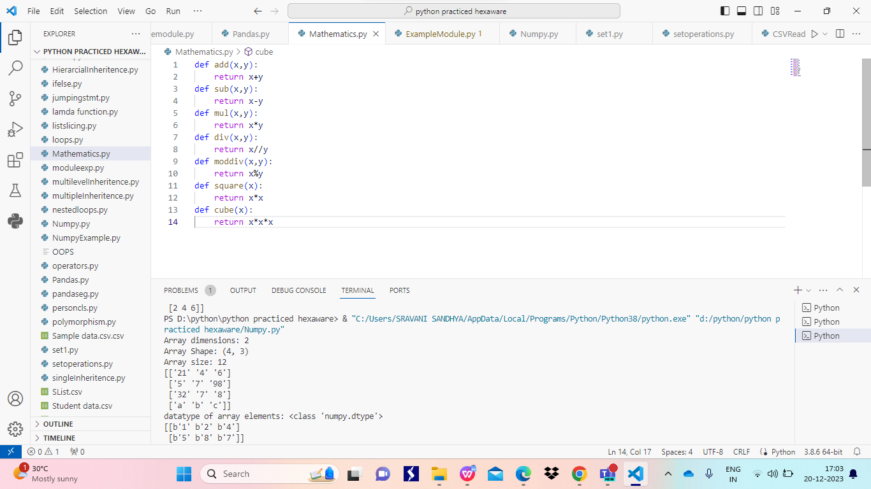

In other python file named ExampleModule Mathematics module is imported and renamed as m

Using m modules all operations in the Matheatics module are performed

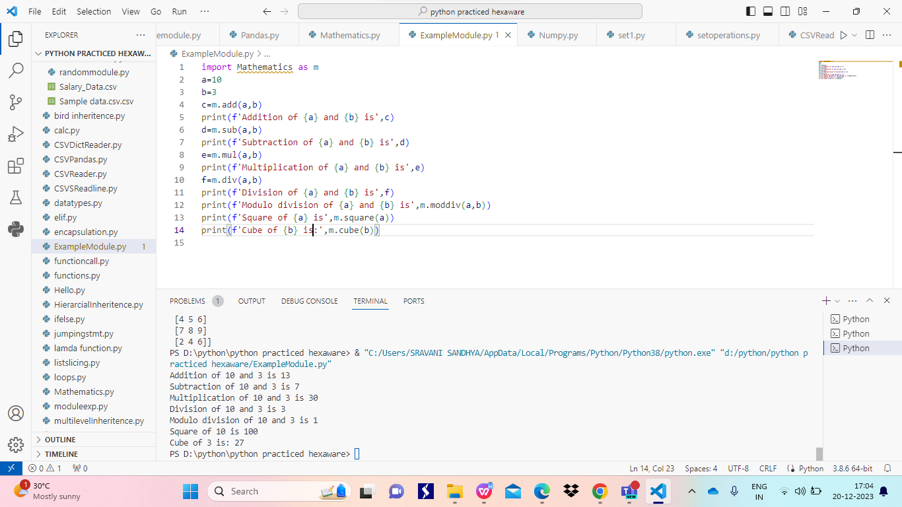

1. Explain Pandas and numpy using Examples in PYTHON

Pandas is a module which helps to read and write the csv file

In order to work on data with huge values we can use pandas to read those csv values

We use read_csv() method to read the file

Syntax:

Pandas.read_csv(“Filename”,delimiter=’,’)

Here filename is name or path of the file from which we want to read

Delimiter is optional

We use DataFrame(),to_csv() methods to write the data into the file

Syntax:

Var=pandas.DataFrame(data)

Where var is a variable

Var.to_csv(‘filename’)

In the below example we have written a data into the file named SList and read from it using pandas

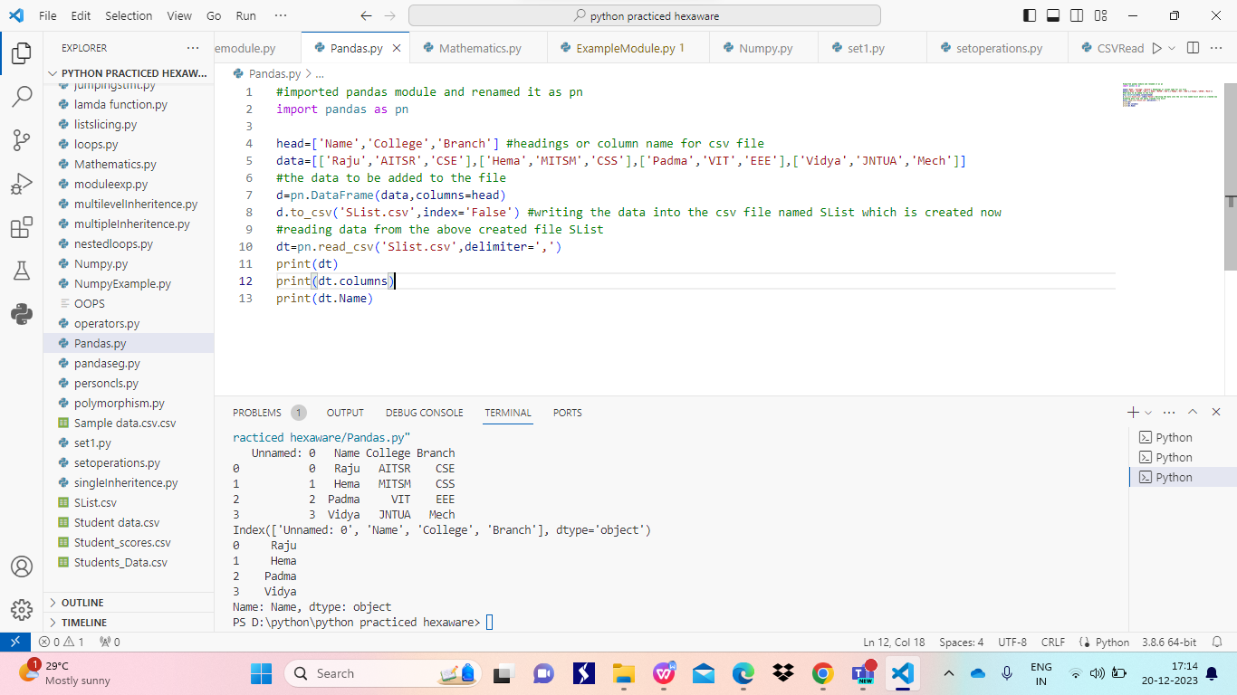

Numpy:

It is also a module which deals with the multidimensional arrays and processing of n dimensional array

It can create and process the arrays

It can perform various operations on arrays like adding subtracting multiplying, … two arrays

It can reshape the array into different shapes that can be possible for same array size

It can sort the array and give min, max ,sum ,cumsum valuse for overall array or rowwise or column wise

All these operations can be performed on array in python file only when numpy module is imported

In the below example numpy module is imported and renamed as np

